**The University of Newcastle**

**School of Information and Physical Sciences**



**CompSci and InfoTech Work Integrated Learning**

**COMP3851A – 2024**

**Progress Report**

**Authors:**

**Tajbir Singh Bal** c3434693

**Jason Eng** c3426445

**Mai Huy Nam** c3435372

**Sudhan** c3435375

**Ingyin Phyo** c3420347

**Arthhur Yu Hong Lee** c3412857

# Table of Contents

**Table of Contents 2**

**SECTION I 3**

Project Title 3

**SECTION II 3**

Research Background 3

**SECTION III 3**

Aim 3

User-friendly 4

**SECTION IV 4**

Methods and Activities 4

**SECTION V 4**

Results 4

**SECTION VI 5**

Ethics 5

**SECTION VII 5**

References 5

**SECTION VIII 6**

Appendix 6

**FONT: TIMES NEW ROMAN**

**FONT SIZE: 12 (16 FOR HEADING)**

# SECTION I

## **Project Title**

A Complete Guide Website For New Student Progress Report

# SECTION II

## **Research Background**

LearnLink is currently engaged in a project to create a freshmen orientation website for first-year students at the University of Newcastle based in Australia collaborating with PSB Academy, Singapore. Understanding the various needs of freshmen perspectives, Learnlink is dedicated to developing unique digital solutions in close connection with first-year students. The orientation website's main objective is to help new students get around campus by providing thorough information on assistance with general inquiries, student associations, and campus facilities.

The LearnLink program aims to reduce the nerves associated with starting university by providing an easy-to-use and informative online platform. Although there are already orientation websites, LearnLink’s strategy focuses on modifying solutions to address the particular difficulties experienced by UON students. Working closely with the institution and conducting comprehensive research are necessary to make sure that any gaps in the materials are addressed on the website. As of right now, the project is in the testing and design phase, and it looks quite likely that it will be completed by the deadline. Unexpected difficulties during this stage, though, could make the project's completion less likely.

LearnLink identified early in the design process that a user-friendly, easy-to-use, and detailed website design was required to attract freshmen and boost the orientation of the website. After evaluation, it was found that neither PSB Academy nor the UON website entirely satisfied the freshmen' needs. In order to meet the demands of UON students, LearnLink created a distinctive orientation website that easily offered focused content and feedback. The orientation website makes sure that new students have access to the necessary information to successfully navigate their academic path by providing thorough information on campus resources, student services, and relevant resources. Additionally, the website's layout can make the content management system easy to edit and update content quickly and effectively, guaranteeing that it is current and relevant. Administrators can easily and quickly adjust to shifting requirements and conditions because of this flexibility, which improves the overall user experience for students.

We oversaw the development of the orientation website through UON academic goals, making sure that it adhered to the criteria and objectives of the university. Information management, user-friendliness, and user experience design comprise the project's primary background domains. The project team learned about the latest trends and best practices in creating orientation materials for first-year students by conducting a thorough literature analysis in these areas. Understanding that new students had difficulties adapting to university life and finding necessary information served as the basis for the initiative. Although there are already websites and resources for orientation, an altered version that meets the unique needs of University of Newcastle students was required. By developing an extensive and user-friendly orientation website that offers quick access to campus resources, student services, and other related data, the project aims to close this gap.

By learning and analyzing the website from the University of Newcastle and other university websites, the project team was able to identify important areas for development and create a targeted orientation website that fits the needs of first-year students. The project's continued adherence to academic best practices and scholarly research was made possible by visiting numerous relevant uni websites. The project's overall goals were to improve the quality of school life for students and help newcomers integrate successfully into the University of Newcastle community.

# SECTION III

## **Aim**

Freshman students may be overwhelmed by the new journey they are about to embark on, providing a well-organized freshman website to guide them through this process will put them at ease. That is the main goal of LearnLink, to improve the student experience by providing a well-organized and high-performing user-friendly interface. Students entering their first year will have peace of mind knowing they have a well-organized website to refer to in case of confusion. To achieve this, here are the aims we have worked towards for our website:

The orientation website is particularly laid out so that first-year students can easily browse it, making for a smooth and enjoyable user experience. The website strives to reduce confusion and keep users from feeling overloaded with information by implementing sensible design elements and functionalities. For example, by clicking on particular areas, like testimonials, visitors can quickly obtain relevant information and look at statements and descriptions from peers or alumni by clicking testimonials profile. Users can relate to real-life events and viewpoints through this interactive feature, which gives the website an interesting new element.

Additionally, the website includes a step-by-step guide to assist students in navigating through the key components of the orientation process in order to avoid the possibility of user fatigue or information overload. This manual divides the orientation process into digestible parts, like looking through courses, utilizing a to-do list, and reading commonly asked questions (FAQs). The website makes sure that visitors can concentrate on one job at a time without feeling overwhelmed by too many options or distractions by presenting information in an organized and sequential manner.

The most important aspect of a website is the usability as well as the visual appearance, to satisfy these we have created an easily understandable interface with responsive design features so it is easy to use. The interface also has a visually appealing format and design that corresponds with the theme of the UON website. All things considered, the orientation website's layout design, interactive elements, and organized, step-by-step instructions improve its accessibility and efficacy, making it a helpful tool for new students adjusting to life at university.

## **User-friendly**

* Create a visually beautiful and user-friendly user interface (UI) for the website.
* Give priority to a flawless user experience in order to improve usability and engagement.

**Intuitive Navigation**

* LearnLink's orientation website was developed with first-year students in consideration, making it simple to navigate and an easy experience overall.

**Interactive Elements**

* The website's testimonial section enables visitors to interact with real-life experiences and perspectives, which adds interest and richness to the orienting process.

**Step-by-step Guide**

* To avoid information overload and user fatigue, a thorough guide walks students through all of the important aspects of orientation, including course selection, to-do lists, and FAQs.

**Organized Layout**

* Logical and sequential information presentation makes it possible for users to concentrate on a single activity at a time without getting distracted by alternatives or sidetracked.

**Feedback Mechanism**

* LearnLink includes feedback methods, including suggestion boxes or surveys, so that users can share their thoughts about the website and make suggestions for future versions.

# SECTION IV

## **Methods and Activities**

**(250 words)**

Describe the activities undertaken and methods used in your project. Note that this section must be closely related to the aims, i.e. here you must describe the process used to achieve the aims. For example, for a UI development task, probably there will be some requirement elicitation and initial design, followed by several cycles of implementation, testing, and feedback until the interface reaches a stable point.

As this project aim to new UON students, it

UI DEVELOPMENT:

In our project to create a website to improve the university experience for new students at the University of Newcastle, we took a holistic approach that included a number of activities and methods to achieve our goals. To begin with, we conducted extensive requirements elicitation sessions to understand the needs and expectations of our target users. This included gathering feedback from new students and remembering the difficulties we faced when we were once freshman students. Throughout this process, we captured a basic flow of the website, focusing on requirements, navigation, and main pages to ensure alignment with our project objectives. As seen in Figure….

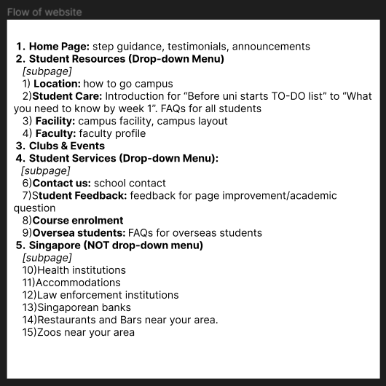

At the same time, we sketched out a low-fidelity prototype, which allowed us to explore different design concepts and validate our ideas before detailed design work. Our main objective was to capture the layout of the website and the main sub-pages that will link back to the home page, the key sub pages we have decided on are, Student Resources, Services, Clubs and Events and About Singapore.

Low Fidelity Prototype

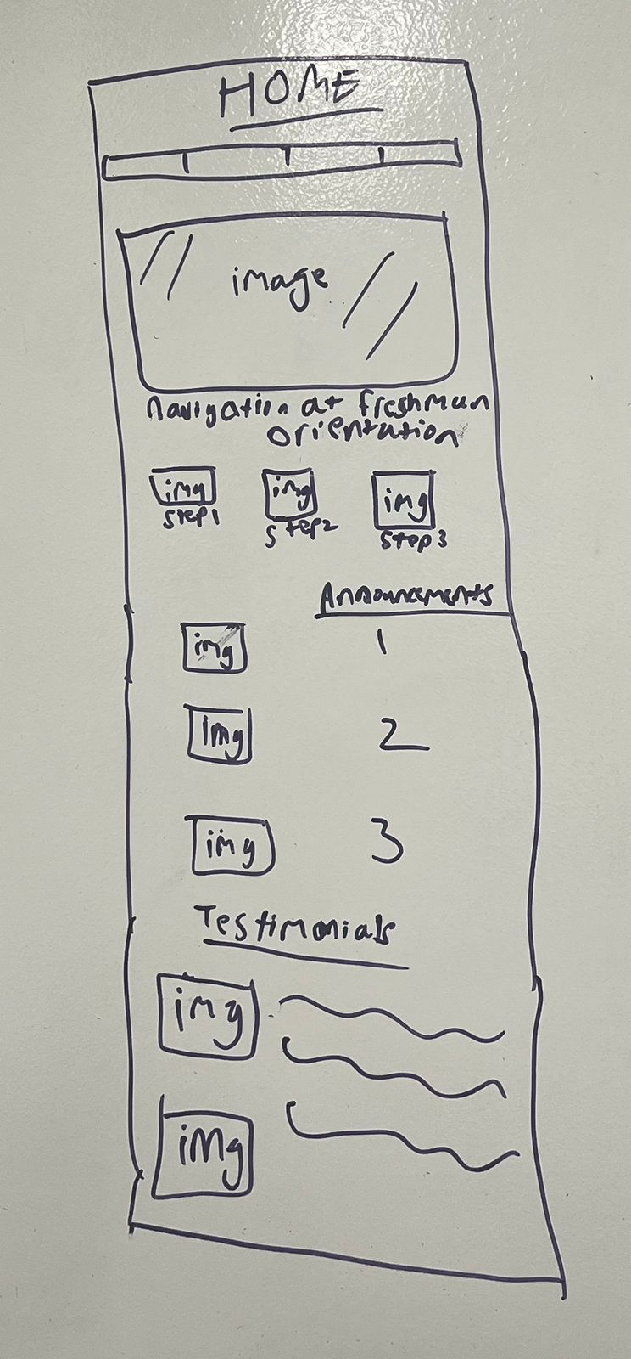 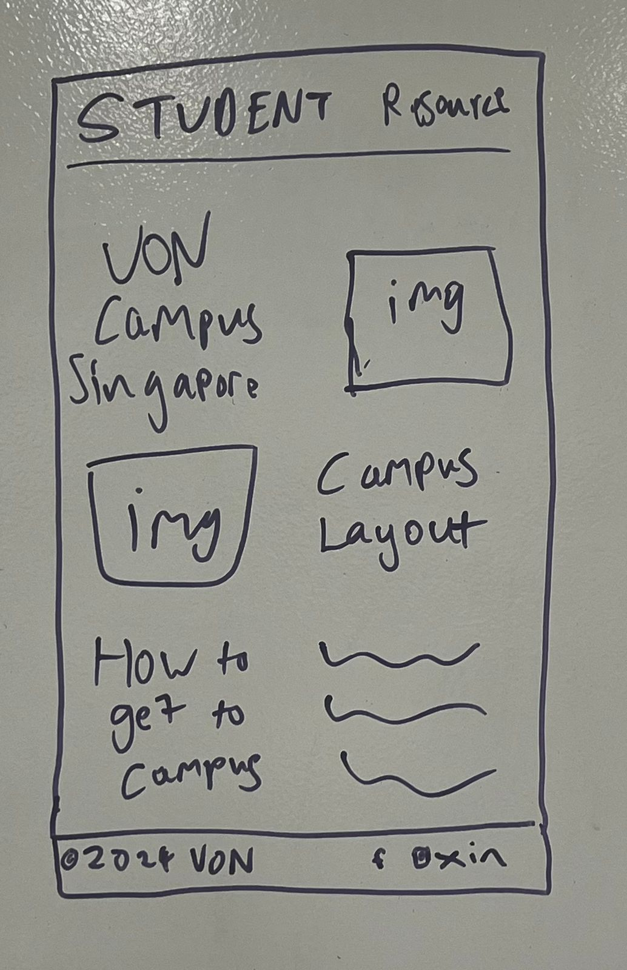

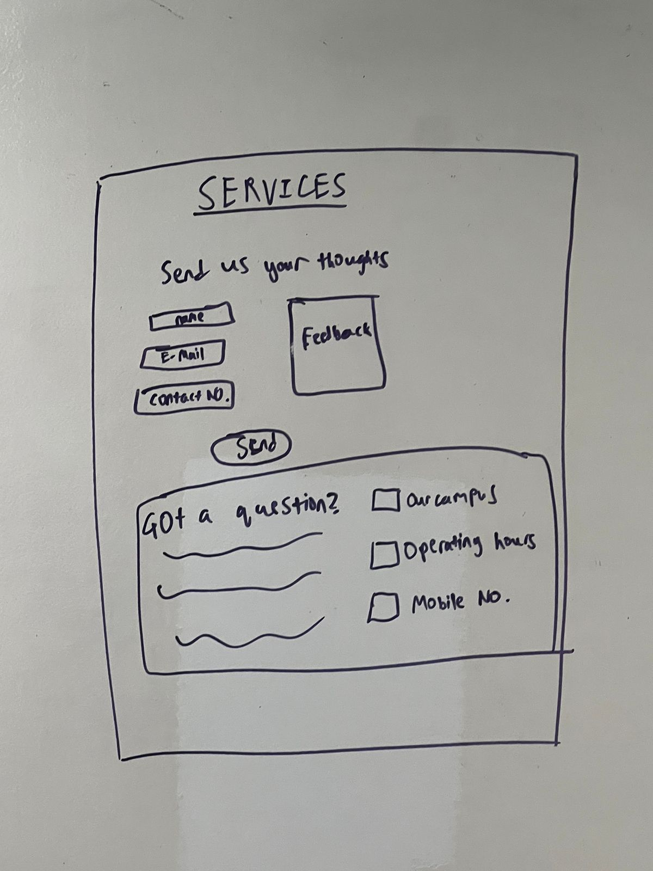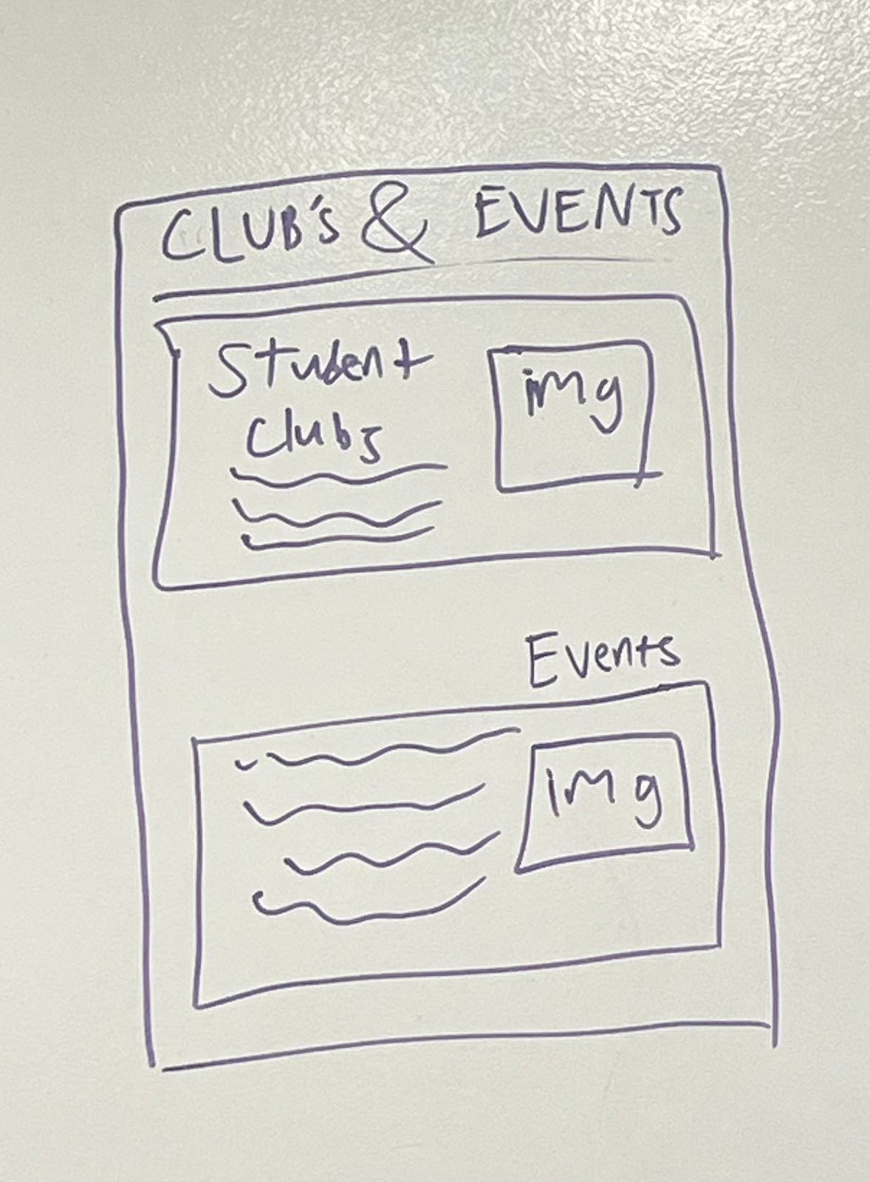

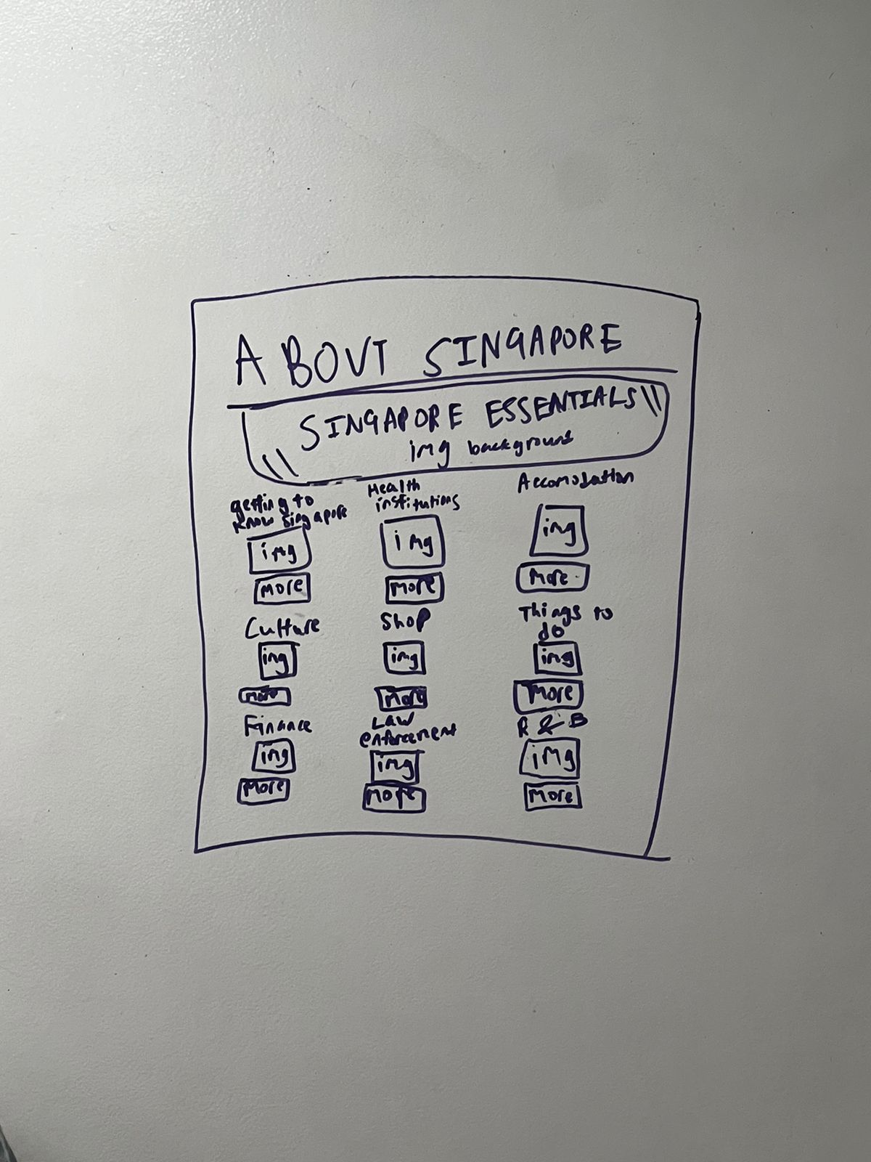

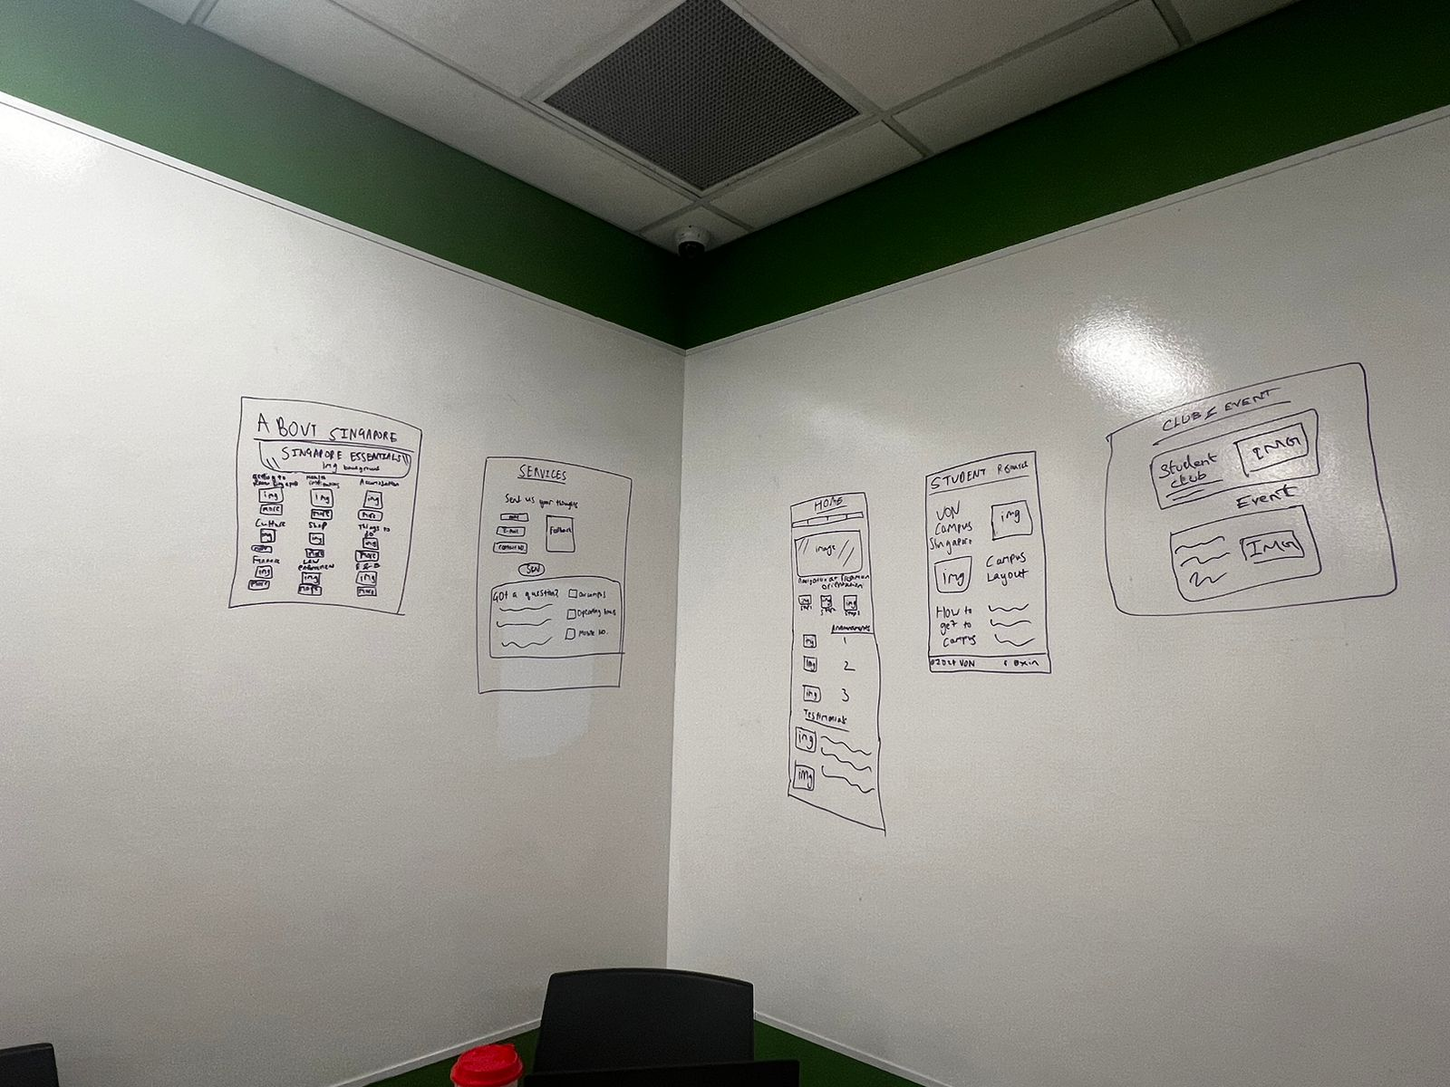

# SECTION V

## **Results**

**(750 words)**

Describe and analyze the results obtained. Again, for the UI development, you can present a screenshot, diagrams, list of functional requirements, etc. Also, please indicate what are the limitations of the experiments, and the implementation itself in terms of performance and flexibility – how could it be extended or modified to suit similar, but different projects? Note again, that the results must reference the aims and methods.

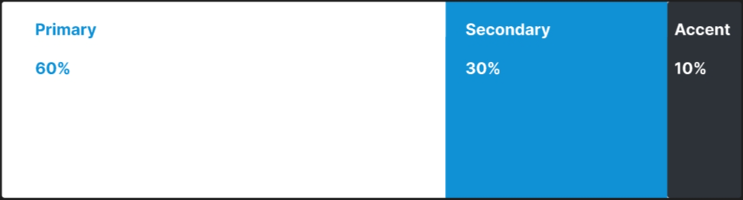

# SECTION VI

## **Ethics**

During the development of the project, ethical concerns may arise and it must be recognized and addressed.

Treating everyone respectfully is highly important even on the internet and having a set of ground rules is very important. Many rules have been established to solve the potential issues such as keeping the content of the website by avoiding offensive language and engaging users to share their feedback about the website so that the problem can be fixed. By establishing the ground rules, it can improve the way the user uses the website.:

1. **Privacy Concerns**

* **Problem:** Gathering personal data from freshmen may give rise to privacy issues, particularly if not managed properly.
* **Mitigation:** Apply strong data security safeguards in effect, like encryption, safe storage, and explicit privacy guidelines. Limit the amount of information gathered to what is required for orientation, and make sure users have given their express consent.

1. **Accessibility**

* **Problem:** The orientation materials may not be accessible to people with impairments due to inaccessible design.
* **Mitigation:** To guarantee that the website is useable by everyone, including individuals with impairments, adhere to accessibility standards such as the WCAG (Web Content Accessibility Guidelines). In order to improve accessibility, test the website using assistive design and make any required changes.

1. **Bias and Discrimination**

* Problem: Certain freshmen groups may be negatively impacted by inadvertent bias in content or design features.
* Mitigation: Evaluate the content and design of the website for diversity and acceptance. Make sure that every resource is inclusive of a range of viewpoints and sensitive to cultural differences. To find and fix any possible biases, take into account input from a wide range of users.

1. **Security Risks**

* Issue: Data leaks or unauthorized access could result from vulnerabilities in the website's security infrastructure.
* Mitigation: Put in place robust cybersecurity safeguards including firewalls, and frequent security assessments. Keep up with the most recent security threats and fix vulnerabilities as soon as possible. Give team members who are in charge of maintaining the website's security tools and training.

1. **Intellectual Property Rights**

* Problem: Intellectual property rights may be violated by plagiarism or the unauthorized use of items protected by copyright.
* Mitigation: Make sure that every piece of content that appears on the website is open source, has the appropriate license, or complies with fair use guidelines. If any content from third parties is used, get permission before using it, and provide credit where credit is due.

1. **Transparency and Accountability**

* Problem: Trust may be compromised by a lack of transparency regarding the website's operation.
* Mitigation: Make sure users comprehend the purpose, rules, and usage guidelines of the website. Give contact details in case someone has questions or comments. Create accountability systems within the group to quickly resolve any problems or queries brought up by people.

In addition, our team upholds accountability and openness by offering the necessary documents including terms and conditions, privacy policies, and cookie policies. These documents explain our dedication to user privacy and provide users with information about the terms of service and cookie usage on our website:

[LearnLink Privacy Policy](https://docs.google.com/document/d/1Hemdpinm9y0argBnuo-ppGvmDVHH2mDPo_VD5QA09dY/edit?usp=sharing)

[LearnLink Cookie Policy](https://docs.google.com/document/d/1-_KEwOUwtF7oVhrVd6fbXZdAjLNItUoDZxm0qCdQl0A/edit?usp=sharing)

[LearnLink Terms & Condition](https://docs.google.com/document/d/1uu-LF5xUHAdpezkSWVuep0DVhoL32_b0ALfLXesad34/edit?usp=sharing)

# SECTION VII

## **References**

(references do not contribute to the word limit): Even if your project is not academic in nature, references are always necessary. Don’t ignore this section. References are important if the reader wants to know more about the overall topic of your work, and what tools and other studies you based you work on.

GitHub

<https://github.com/bigboi00/LearnLink>

Johnson, L., Adams Becker, S., Cummins, M., Estrada V., & Freeman, A. (2017). NMC Horizon Report: 2017 Higher Education Edition. The New Media Consortium.

Siemens, G., & Gasevic, D. (2012). Guest editorial—Learning and knowledge analytics. Educational Technology & Society, 15(3), 1-2.

# SECTION VIII

## **Appendix**

UseCase of Freshman Website

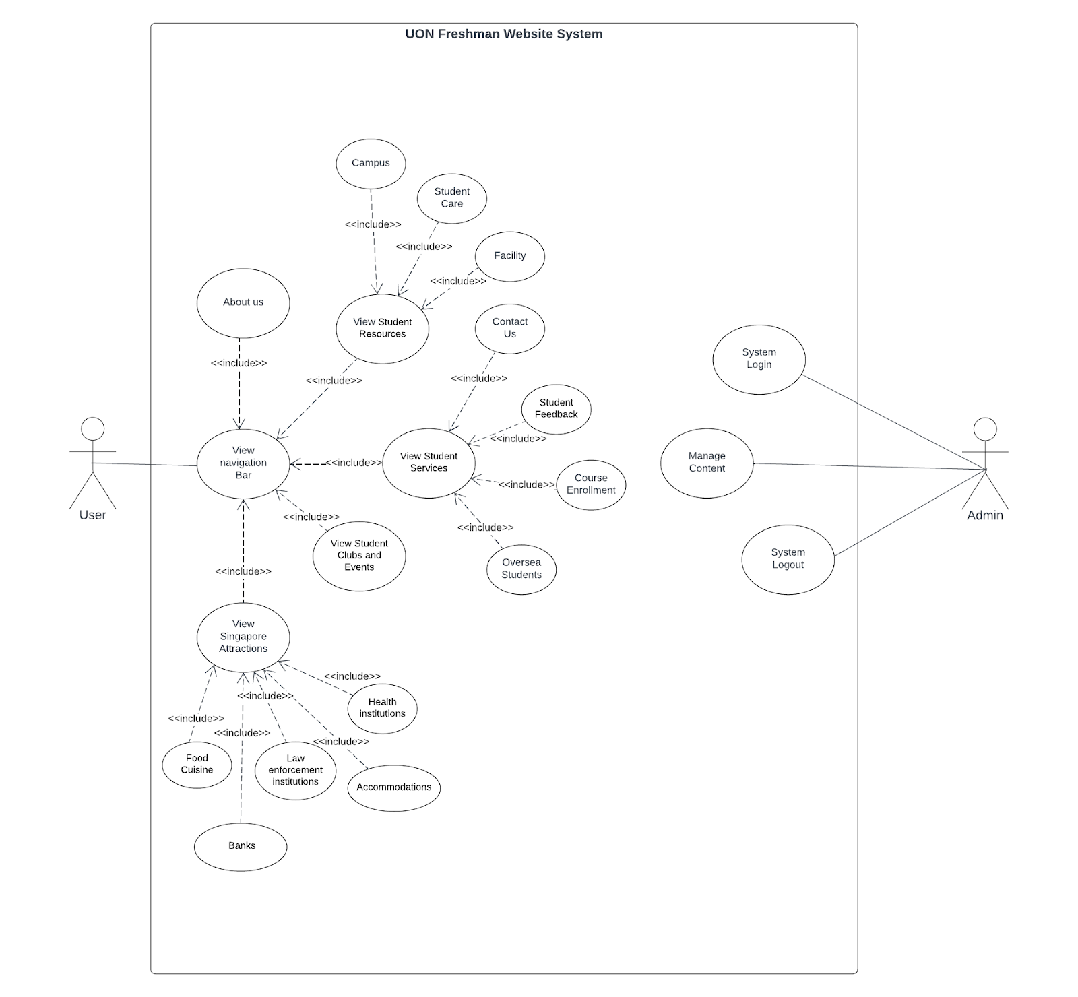

Class Diagram of Freshman Website

